Visualization of results

* Key Chart
* Ideal Brake Force Distribution I Curve VS ECE Regulation Curve

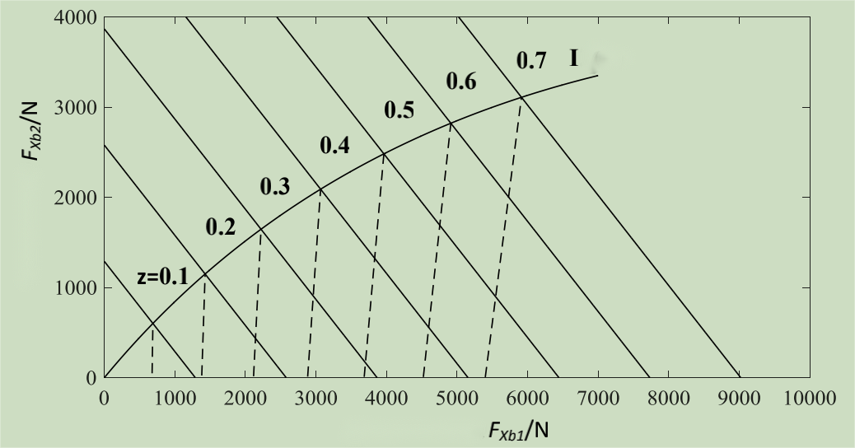

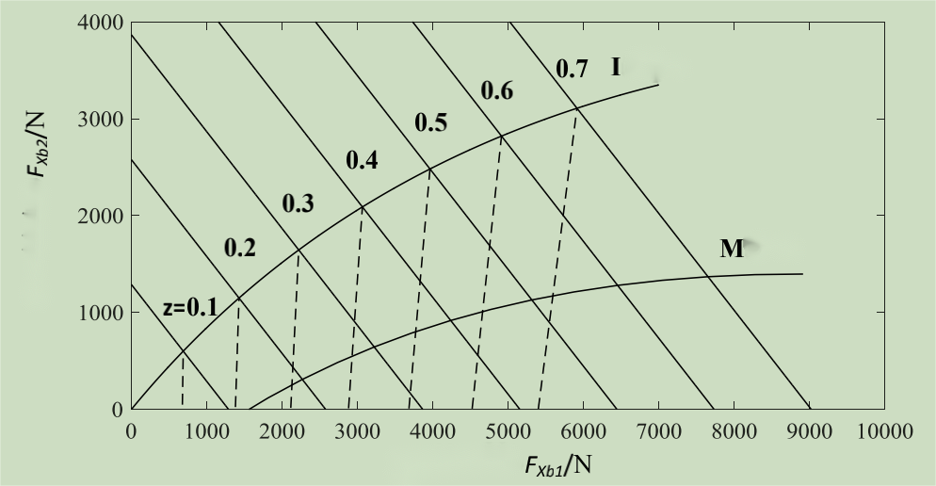

* Fuzzy Control Input Surface/Output Surface

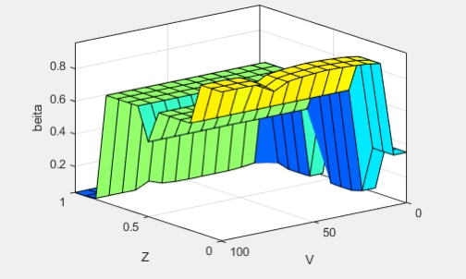

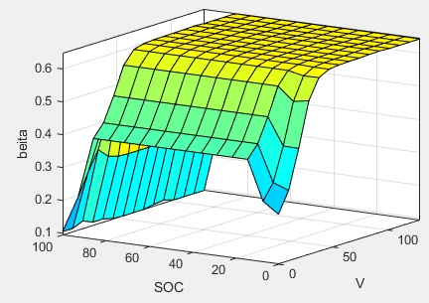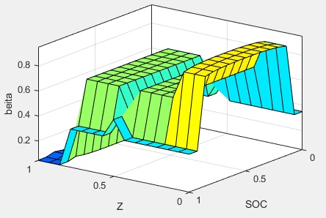

* Control Strategy Comparison

Fixed Proportional Allocation Strategy VS Fuzzy Control Strategy Architecture

